- Create VPC with 2 private and 2 public subnets.
Search VPC in search bar > create VPC > VPC only > kept VPC range as 172.168.0.0/16 (65,536 Ips)> create VPC.
Successfully created the subnet
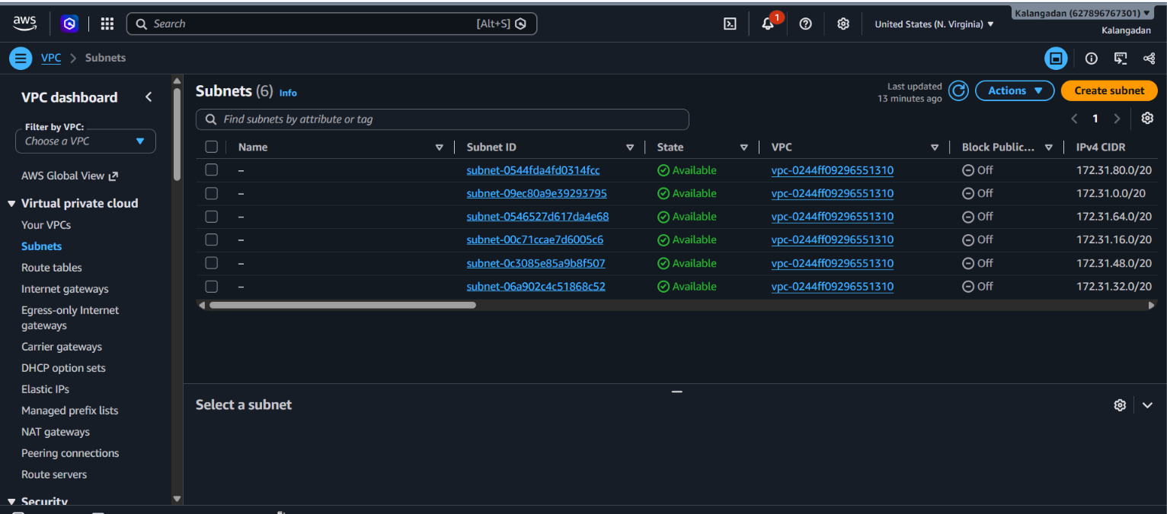
Go to subnet > create subnet > create VPC ID as created just now >giving these values to each subnet > and click on add new subnet
1public subnet: 172.168.1.0/24 (256 Ips) us-East-1a
2public subnet: 172.168.2.0/24 (256 Ips) us-East-1a
1private subnet: 172.168.3.0/24 (256 Ips) us-East-1a
2private subnet: 172.168.4.0/24 (256 Ips) us-East-1a
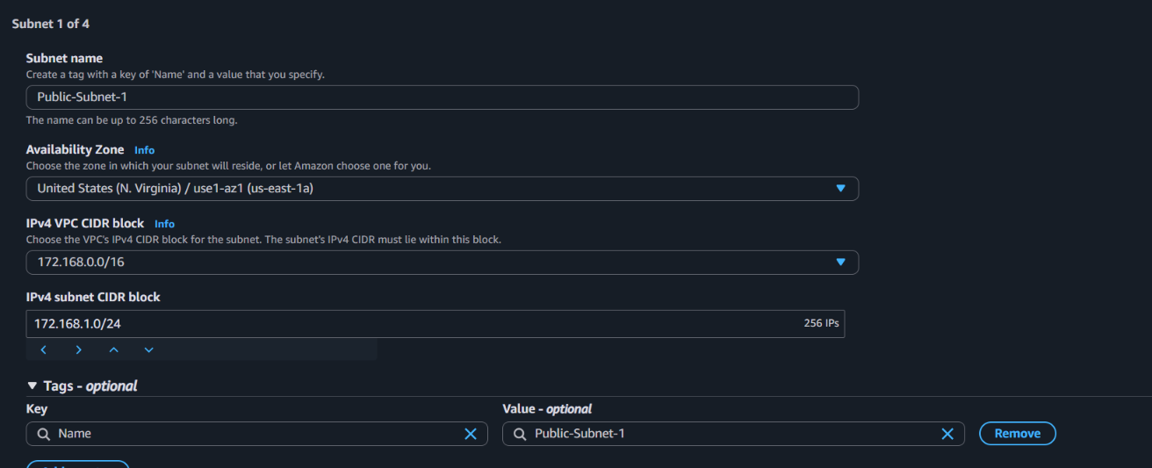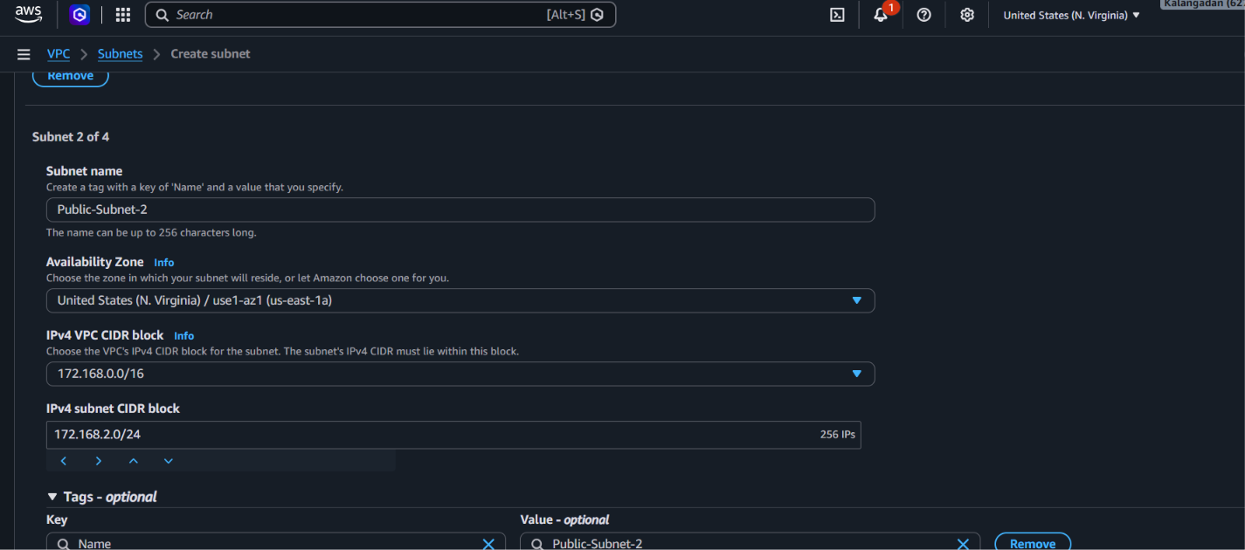
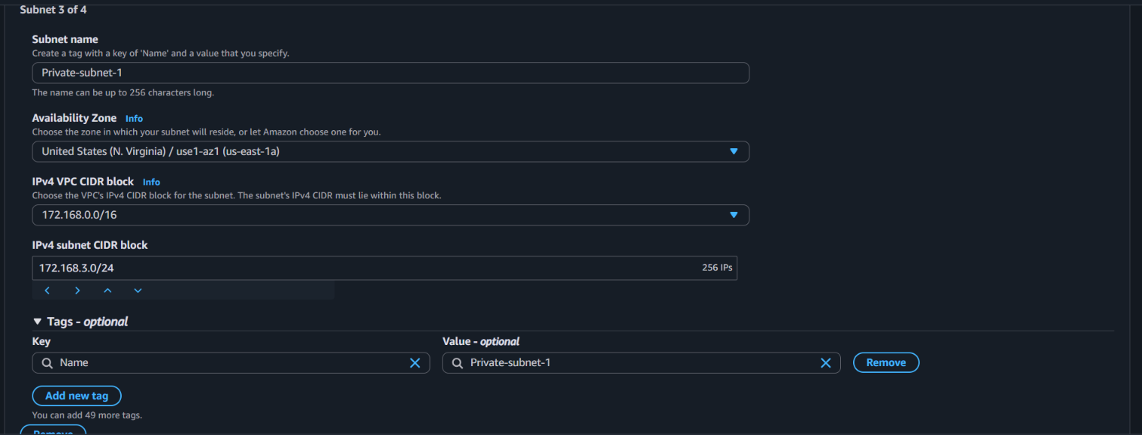
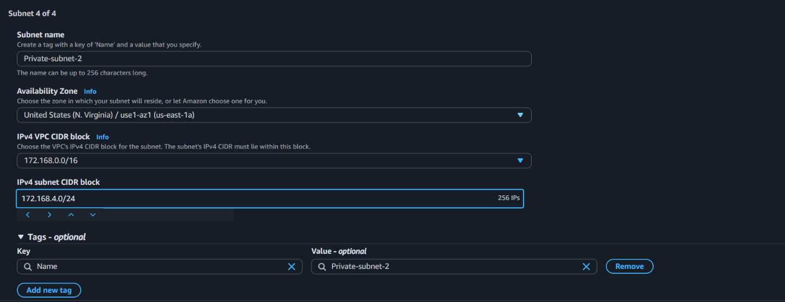
Then created 2 public and 2 private subnets.
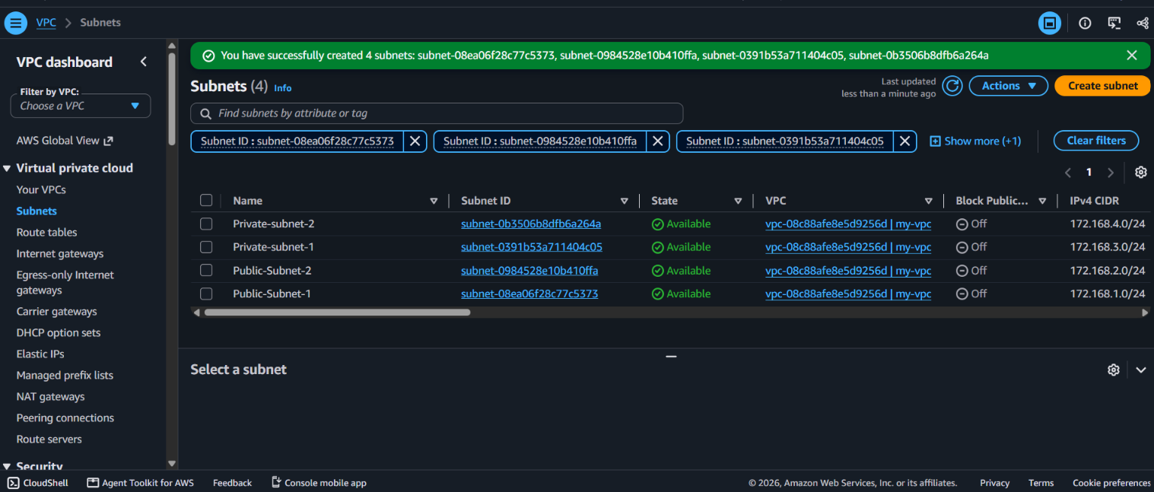

2. Enable DNS Hostname in VPC.
VPC > your VPC > select your created VPC > actions > edit VPC settings > check box of ENABLE DNS HOSTNAME > save the changes
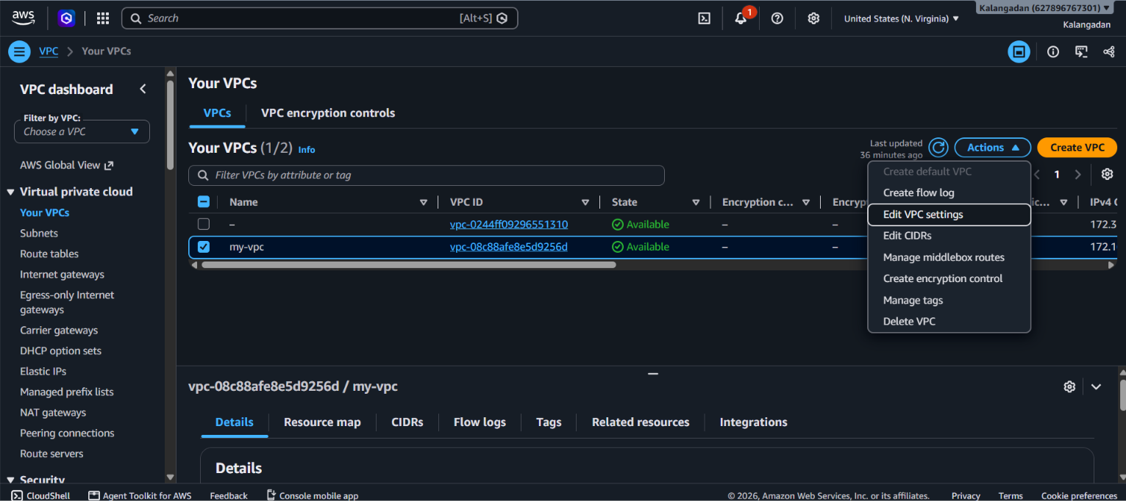
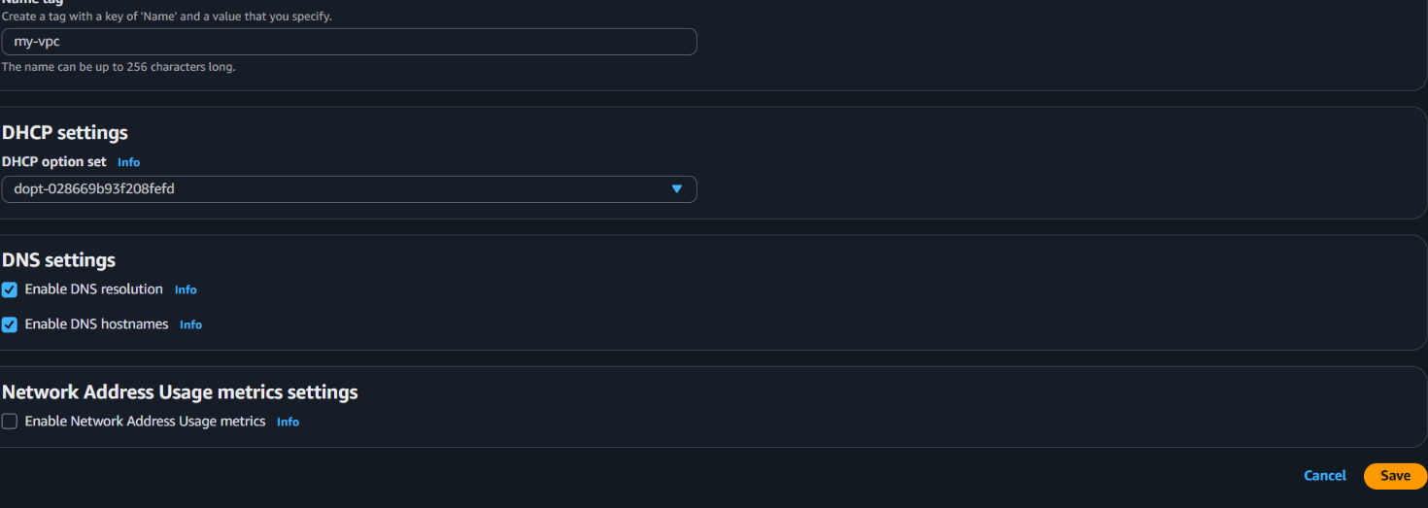
Enabled the DNS hostname
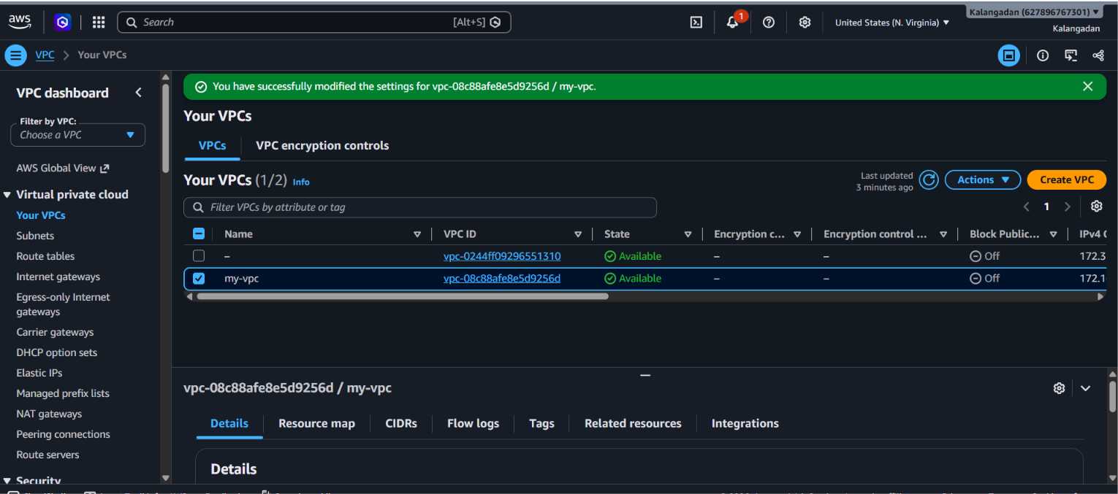
Use of this enabling: now we need to enable DNS hostnames so that whenever we create an EC2 instance in the public subnets, it automatically gets a public DNS name (like ec2-xx-xx-xx-xx.compute-1.amazonaws.com)."

- Enable Auto Assign Public IP in 2 public subnets.

Subnet > Click any one public subnet > actions > edit subnet settings > Enable auto-assign public IPv4 address (Auto-assign IP settings section) > save > then repeat this process to another public IP subnet (public subnet 2)
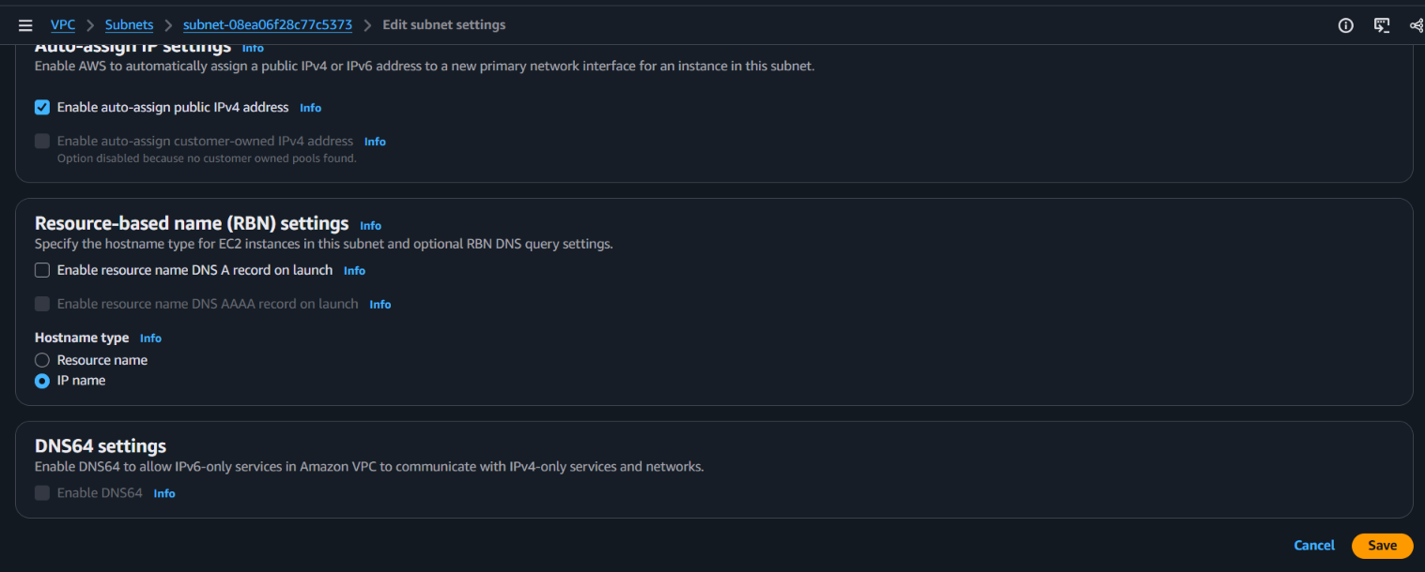
Successfully done on the 1 public subnet
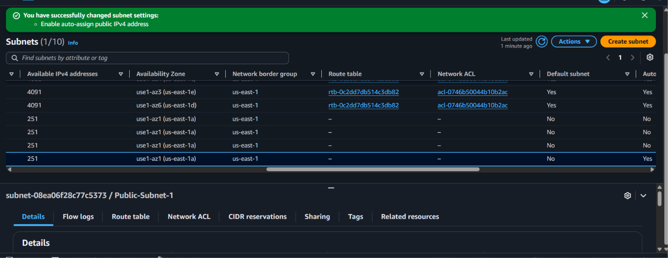

Successfully done on the 2nd public subnet
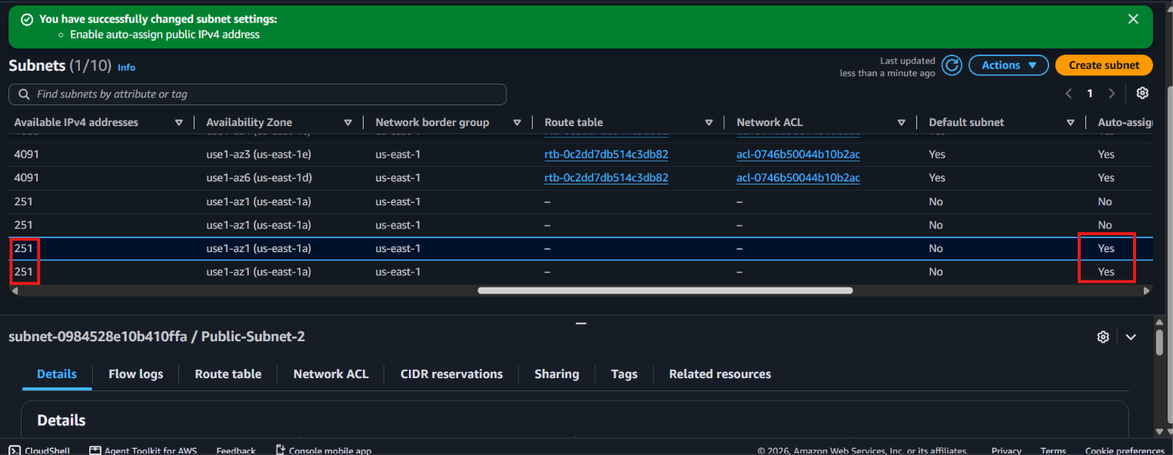
Now we need to ensure that whenever we launch an EC2 instance in our 2 public subnets, it automatically gets a public IP address (so that we can access it over the internet)."

- Add 2 private subnets to the private route table.
Path to add private subnets to private table: create RT > edit subnet associations.
RT > create RT > select created VPC > create > actions of private RT > edit subnet associations > select our created two subnets > save associations >
Created the private RT
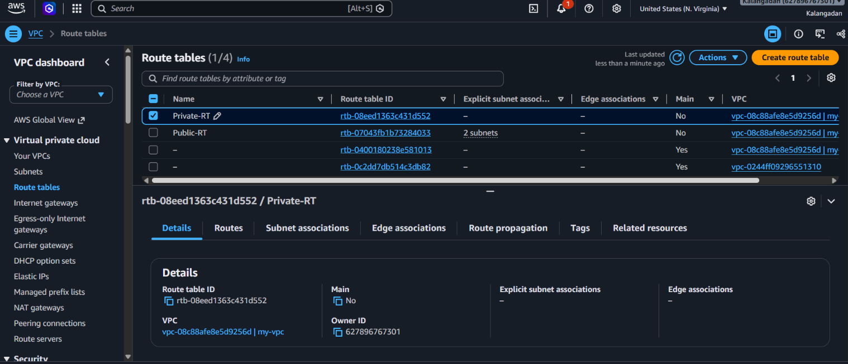
Attached the RT to subnets
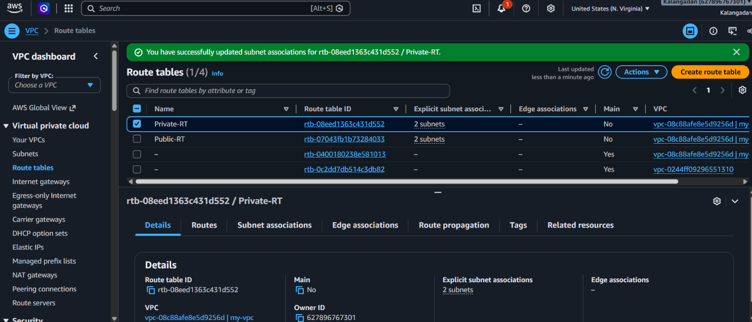
Now we need to associate our 2 private subnets with the private route table so that they remain secure and do not get direct access to the internet
"A Route Table is like a traffic police officer or a GPS route.
We need to associate (link) a subnet with it so that:
- Public Subnet: Its servers can get a path (via the Internet Gateway) to reach the internet.
- Private Subnet: Its servers can be kept safe and hidden from the internet.
If you don't link them, AWS won't know where to direct the traffic."

- Add 2 public subnets to the public route table.
Path to add public subnets with public RT: create RT > add routes > select created IGW > edit subnet association tab > add public subnets
Route tables > create route tables > keep name as Public-RT > my-vpc > create route table > then select the created public RT > routes in below > click on edit routes > add route > select 0.0.0.0/0 > selected our created IGW > save changes > subnet associations (tab) > edit subnet associations > select two public subnets > save associations >
Created successfully.
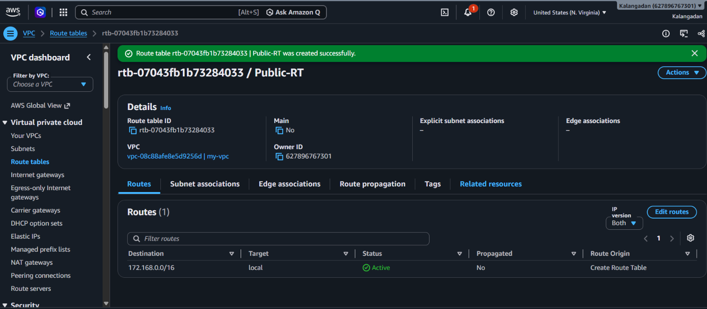
Attaching this RT to my created IGW
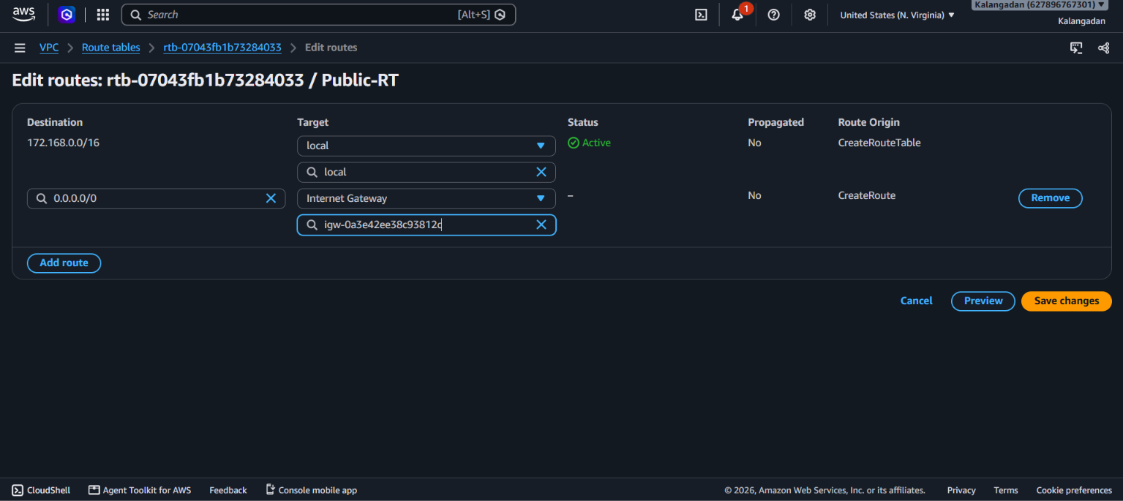
Attached IGW to RT.
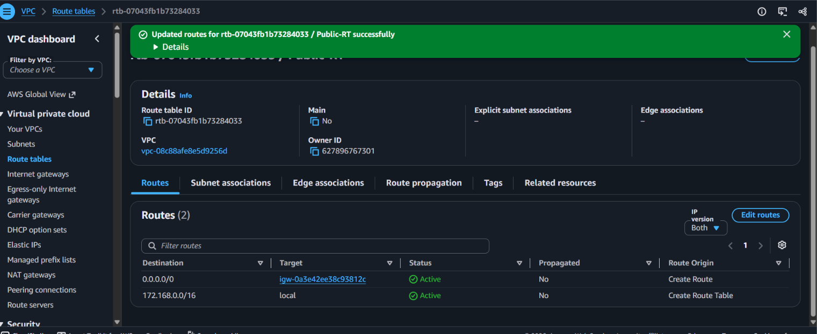
"A Route Table is like a traffic police officer or a GPS route.
We need to associate (link) a subnet with it so that:
- Public Subnet: Its servers can get a path (via the Internet Gateway) to reach the internet.
- Private Subnet: Its servers can be kept safe and hidden from the internet.
If you don't link them, AWS won't know where to direct the traffic."

- Public route table will have routes to internet and local.
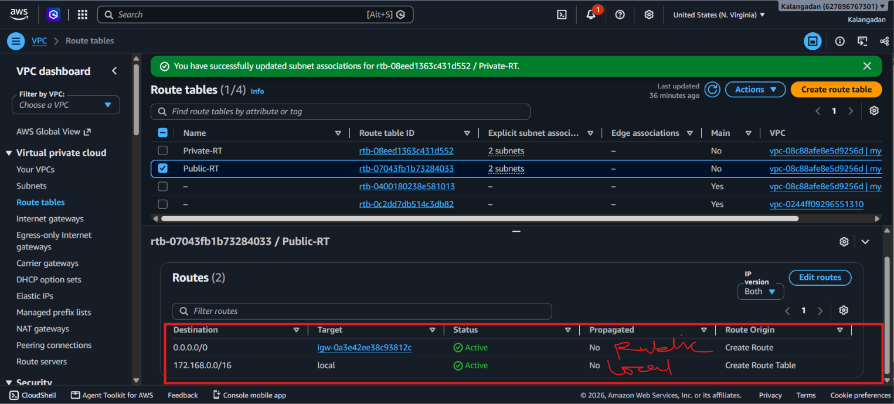
This task simply means that the Public Route Table (Public-RT) should have two traffic rules (routes):
- Local Route: For internal communication within the VPC (172.168.0.0/16 $→$ local). AWS creates this automatically.
- Internet Route: For sending subnet traffic to the internet (0.0.0.0/0 $→$ Internet Gateway)."

- Create EC2 in public subnet with t2. micro and install PHP.
T2 micro is disabled so selected c7
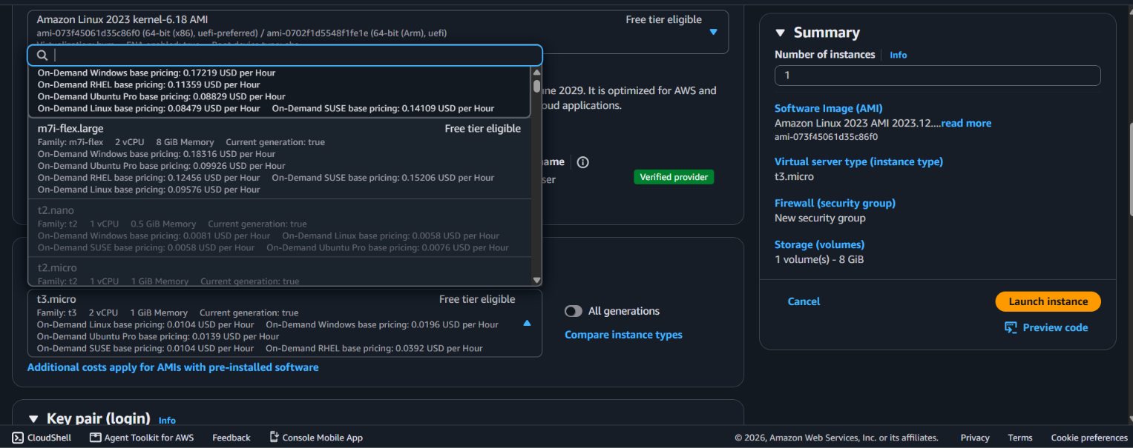
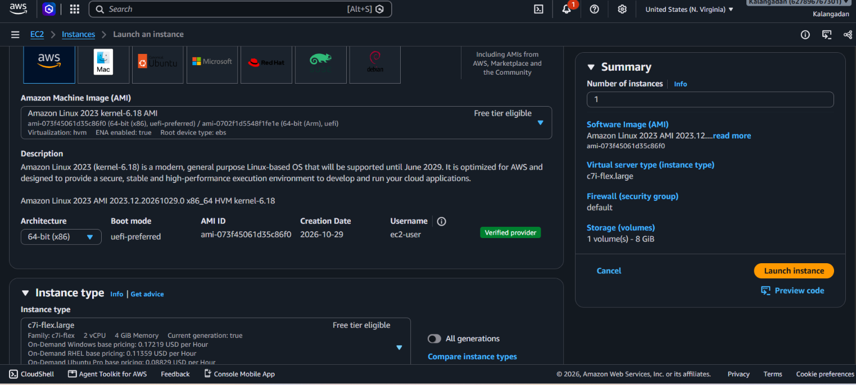
Selected my VPC, public subnet 1, enabled the auto assign public IP created 2 SG with 22 and 80 ports to installation PHP
SSH (Port 22): My IP - Anywhere (0.0.0.0/0)
HTTP (Port 80): Anywhere (0.0.0.0/0)
Then launch the instance
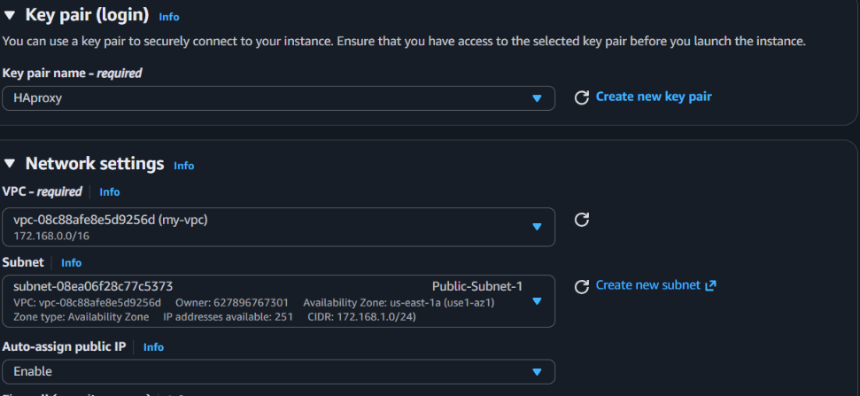
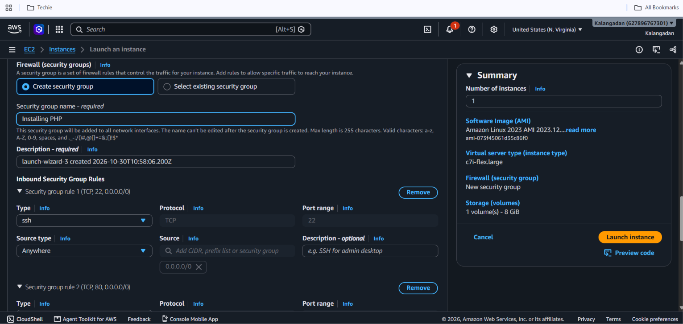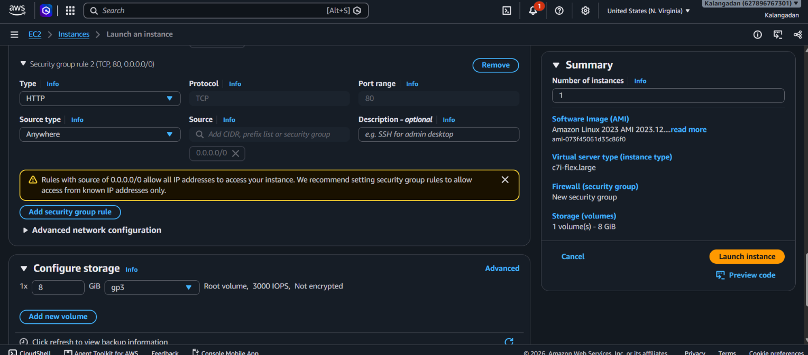
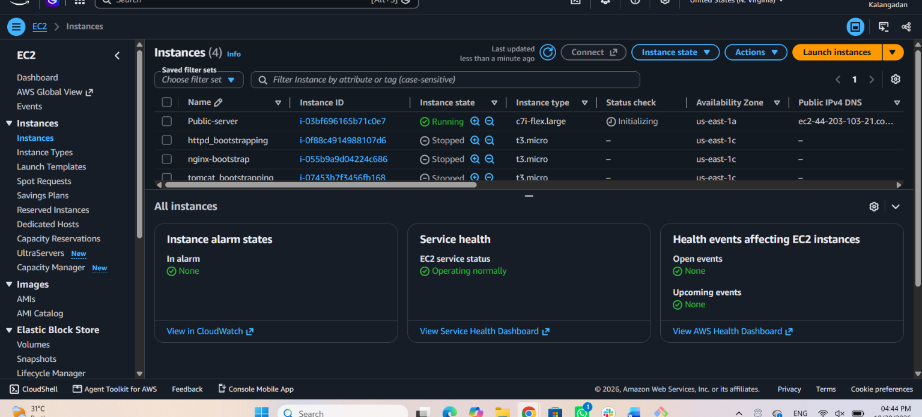
Connected to the terminal then used ssh key to connect remote server then ,
Used these commands :
sudo dnf update -y
sudo dnf install php -y
php -v
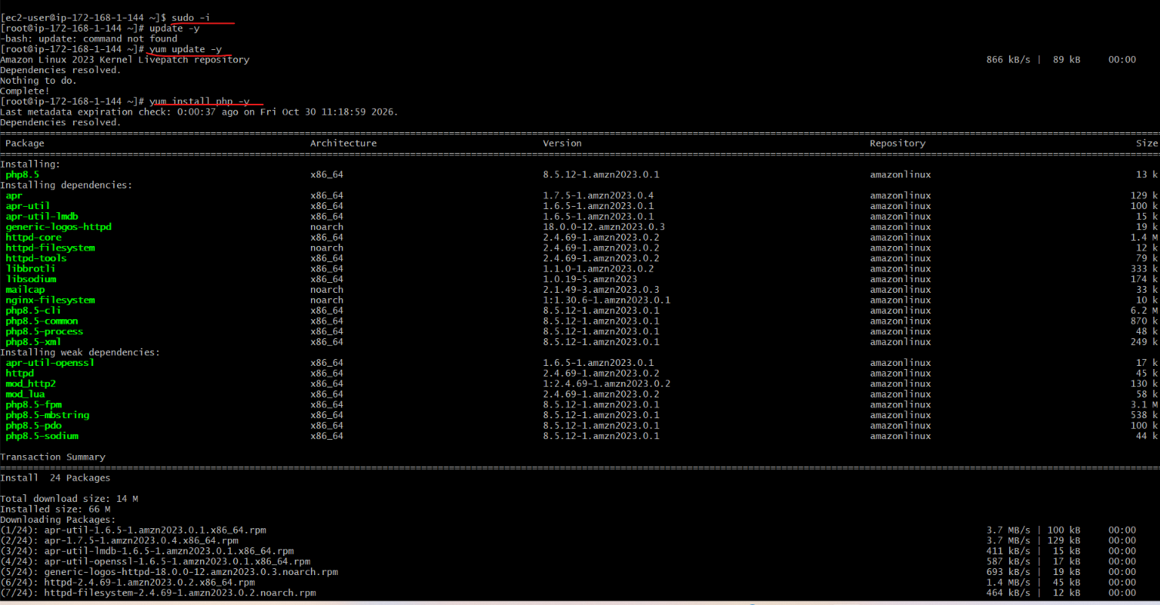
Successfully installed the php
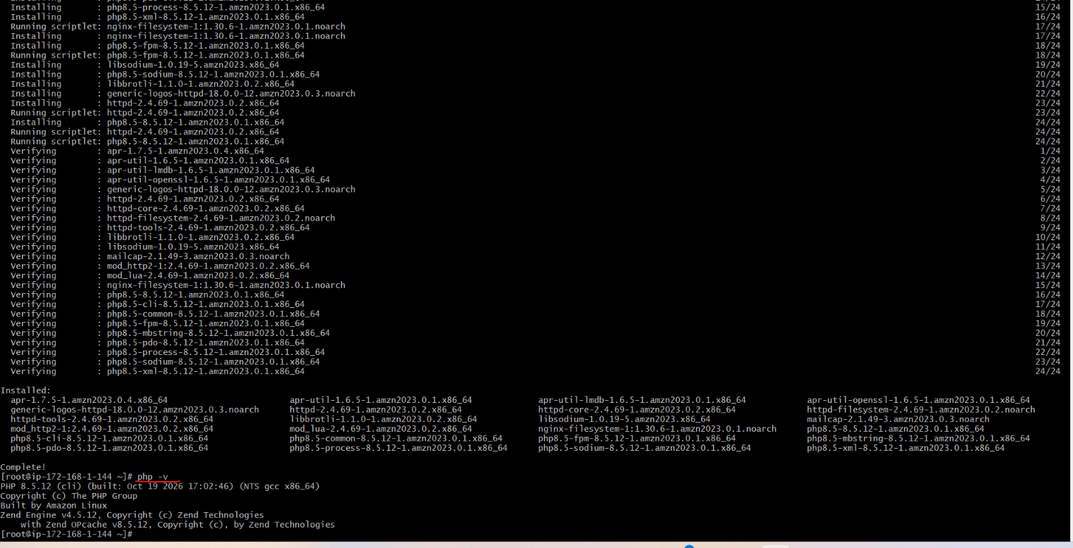

- Configure NAT gateway in public subnet and connect to private instance.
Create Elastic Ip > Create NAT Gateway > Add the NAT route in Private RT > Created instance > connected to the public server > copied the pem key and pasted in the public server > access the private server in the public server > check with the ping command >
VPC > Elastic Ip > Allocate Elastic IP address > allocate > NAT gateways > Create NAT gateway > keep a name to Nat gateway > select our created VPC > zonal > give our created public subnet > Created Elastic Ip > select public > select created Elastic IP > create Nat gateways > Route tables > routes in down > Edit routes > add routes > select Nat gateway > select created our Nat gateway > save changes >

Then created an instance by these steps:
Made private server > custom VPC > selected private subnet > enabled auto assign public Ip > made one 22 SSH SG > launch instance >
Created elastic IP
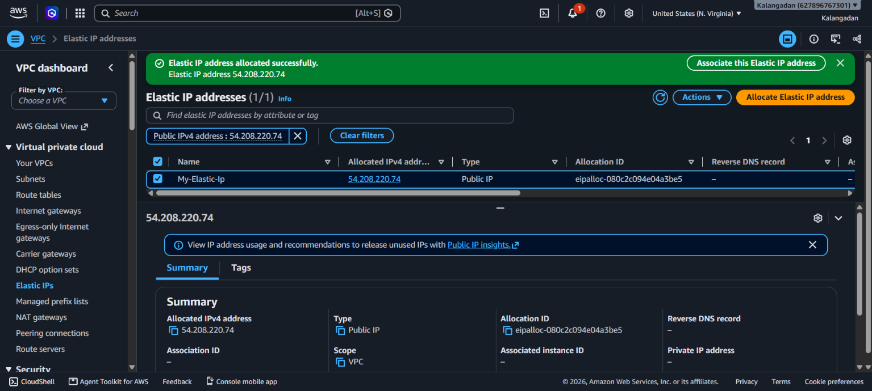
Created Nat gateway
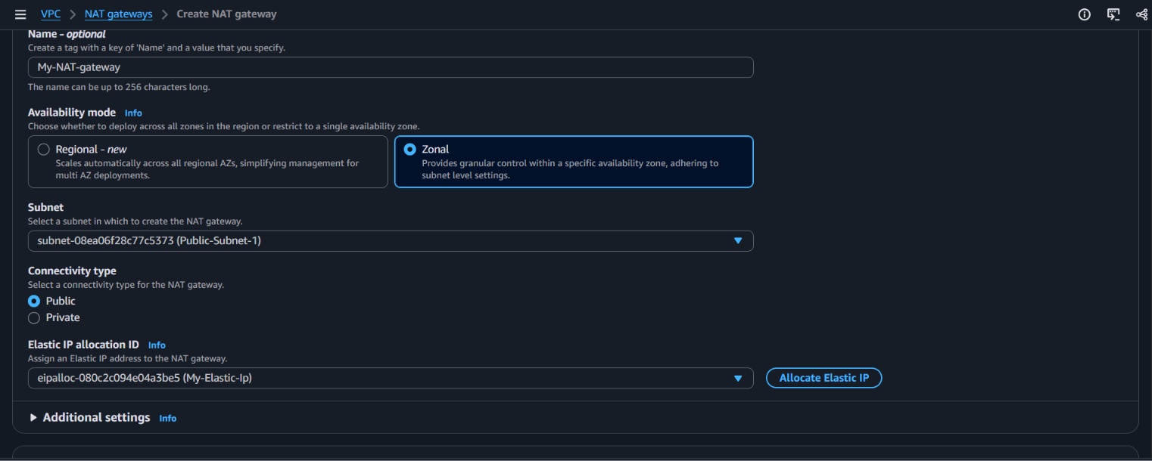
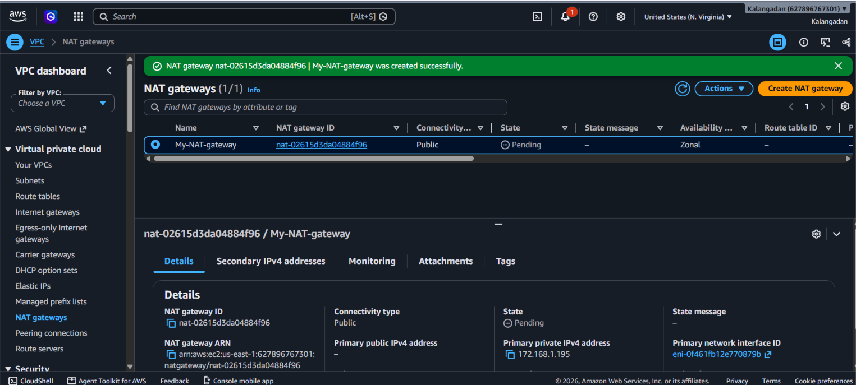
Add the NAT route in Private RT
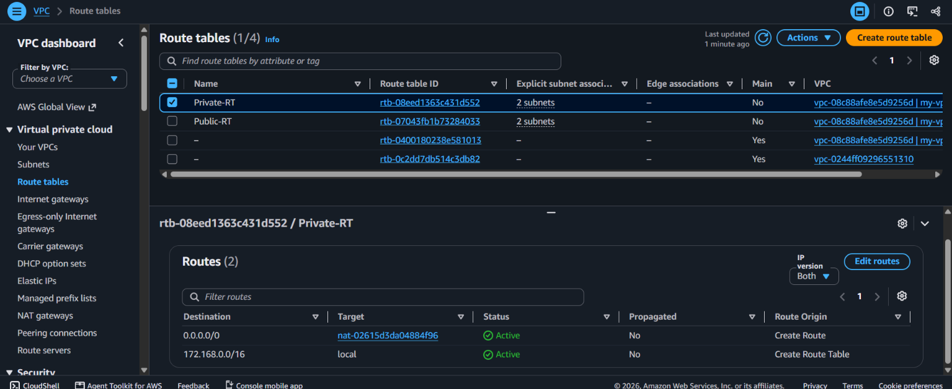
Created instance:
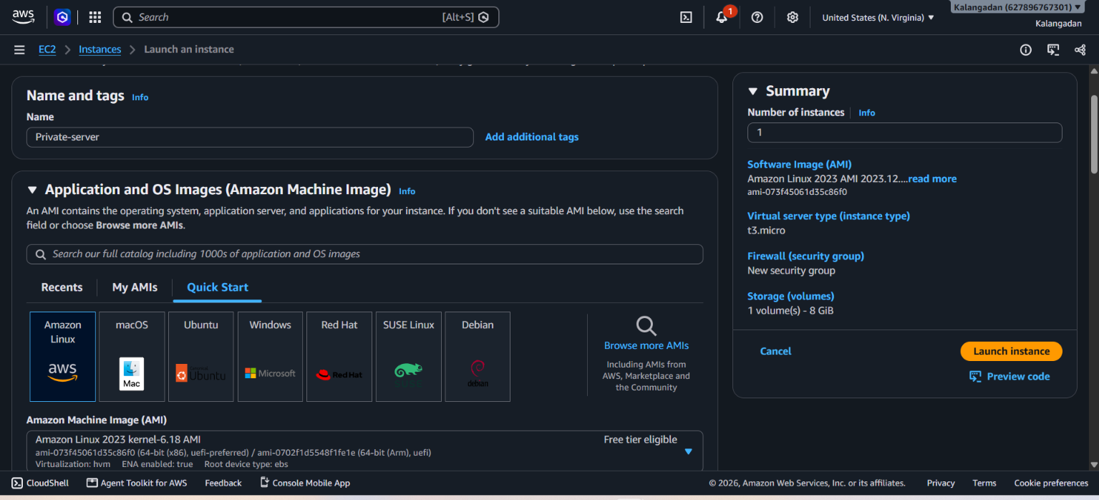
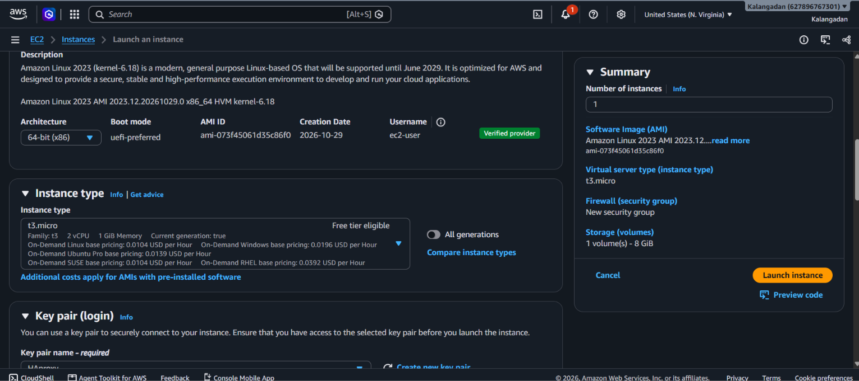
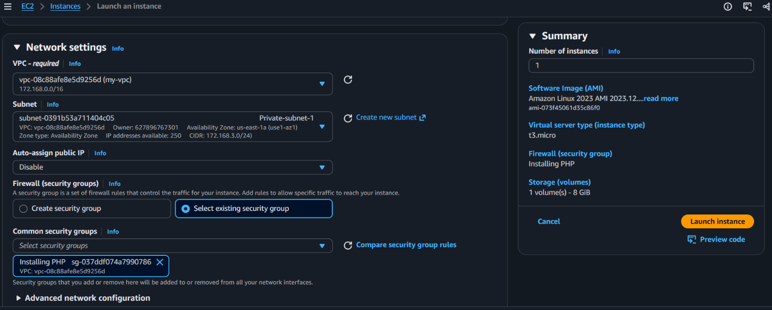
Successfully connected to the private via Nat gateway in the public server
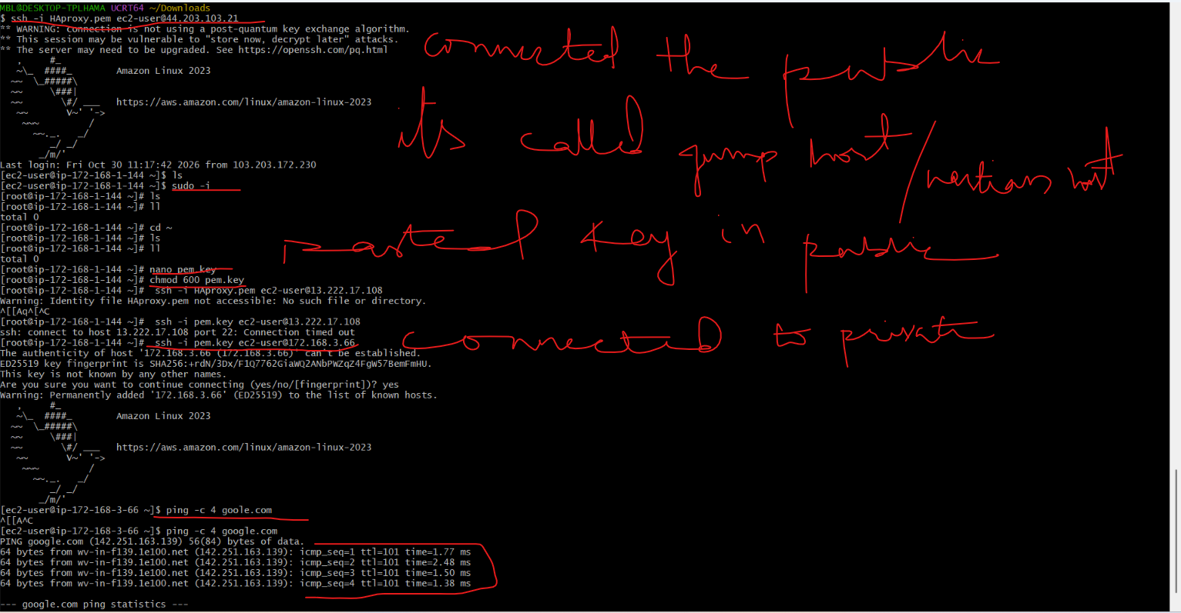

9. Install Apache Tomcat in private EC2 and deploy a sample app.
Used commands in private Ec2
install java-17-amazon-corretto -y : installed java
java -version : checked the version
wget https://archive.apache.org/dist/tomcat/tomcat-10/v10.1.8/bin/apache-tomcat-10.1.8.tar.gz : Downloaded the tomcat 10 through URL not used yum because it will download 9 by default
tar -xvzf apache-tomcat-10.1.8.tar.gz : extract the zip file
mv apache-tomcat-10.1.8 /opt/tomcat : moved the extracted file in tomcat folder to clean arrange
find / -name webapps : find the webapps location
cd /opt/tomcat/webapps : go to that location
mkdir deploy : created a folder to make index.html
cd deploy/ : inter to the deploy folder
nano index.html : deploy this content in that file “ <h1>Hello from Private EC2 Tomcat Server!</h1>”
cd /opt/tomcat/bin : went to this bin file to modify tomcat scripts
chmod +x *sh : gave executive permissions to all script’s files
bash startup.sh : started the service
curl http://localhost:8080/deploy/ : as private Ec2 data will not be open in the browser I opened in the private Ec2 by this command
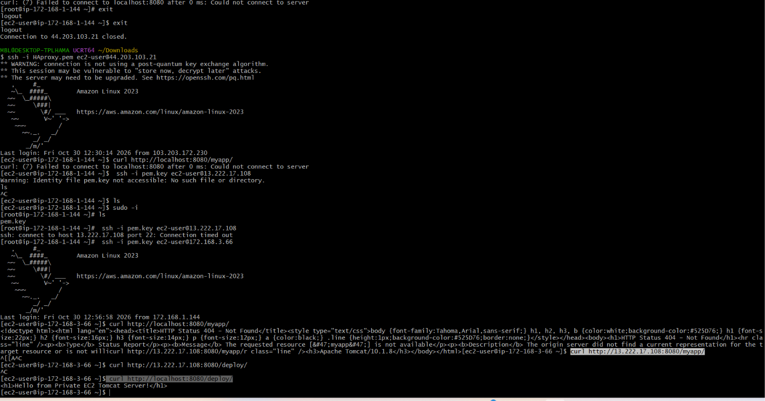
  - . Configure VPC flow logs and store the logs in S3 and CloudWatch.
Create log groups > create se bucket > create 2 flow logs 1 for S3 and one for cloud watch > VPC and paste the S3 ARN > check the logs in lo ggroup
Cloud watch > log management >log groups > keep a name for log groups .
Successfully created
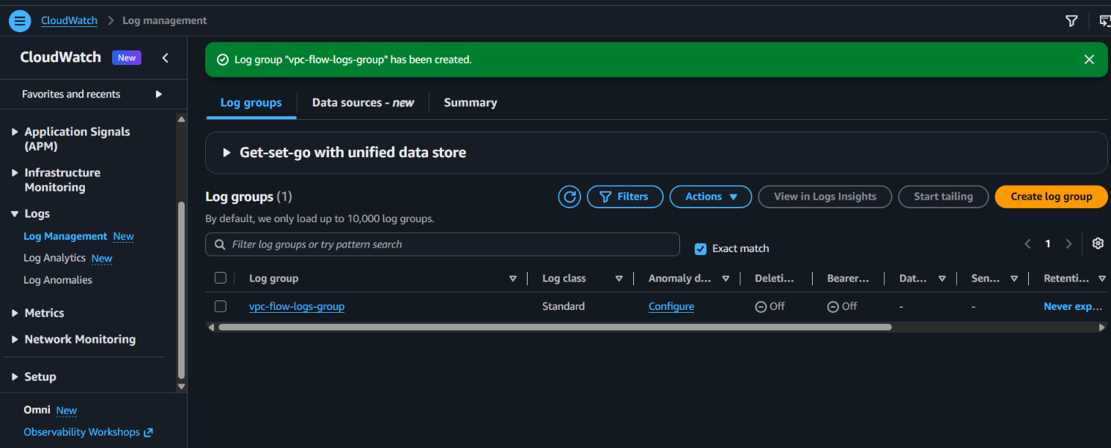

S3 > create a bucket > create a name to created bucket as vpc-flow-logs-bucket-muq
Successfully created a bucket

Vpc > select our vpc > create flow logs > keep a name > select as 1 min > send cloud watch logs > create and use a new service role (VPCFlowLogs-Cloudwatch-1793371730637) > create flow logs
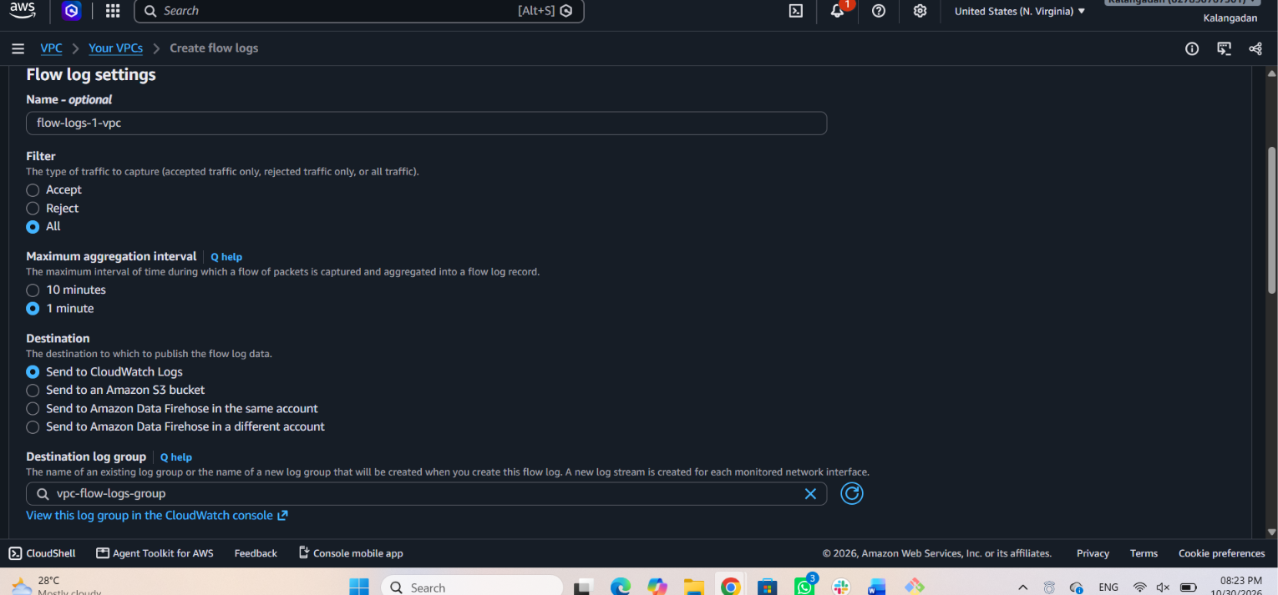
Created flow logs settings successfully
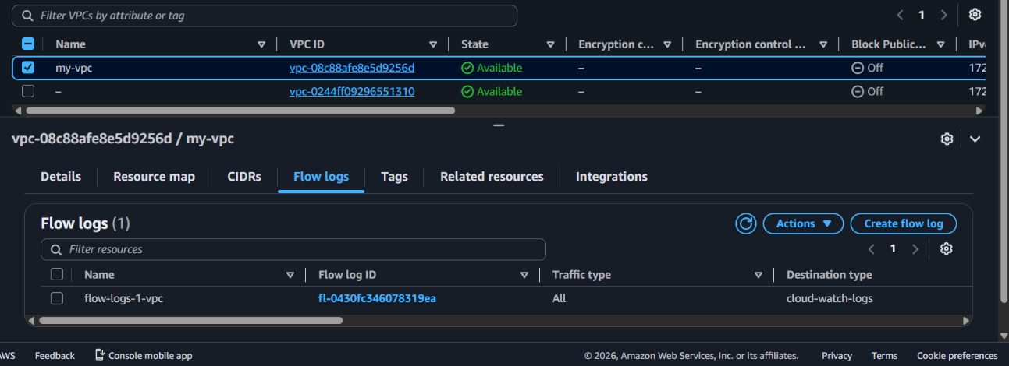
Vpc > select our vpc > create onemore flow logs > keep a name as s3 > select as 1 min > send amazon s3 bucket > copy S3 ARN in S3 and pasted in s3 bucket ARN section > create flow logs

And added 1 more flow log for s3
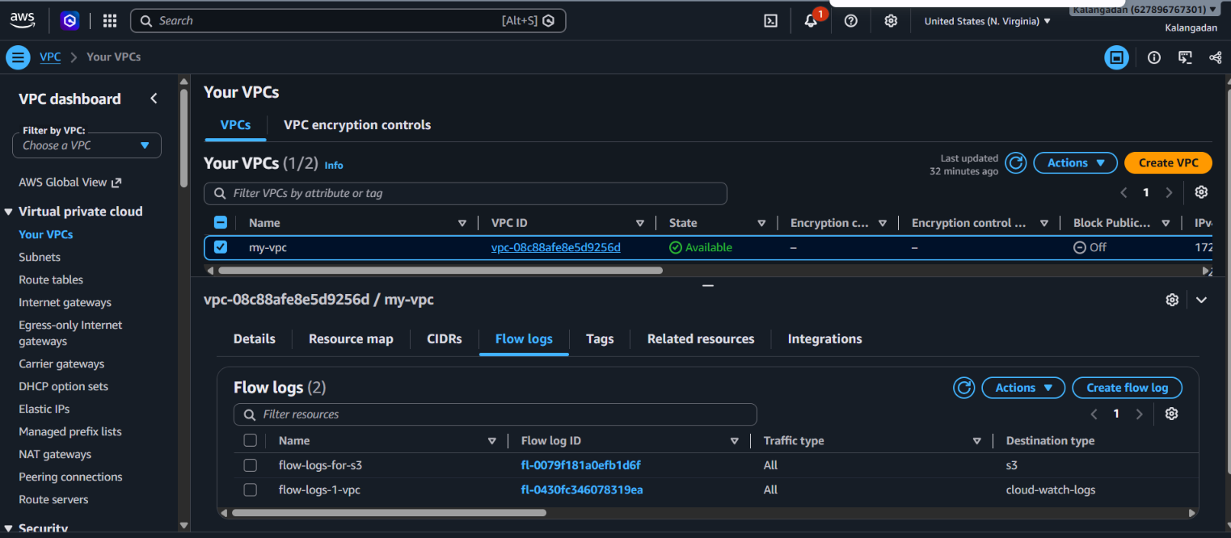
Successfully getting the logs in logs group


